**Reading Homework**

**Week of April 4-April 8**

|  |  |
| --- | --- |
| **Monday** | https://s-media-cache-ak0.pinimg.com/236x/c0/5d/08/c05d08d5e60d86c88596514aa69f0c26.jpgRead the poem three times.  https://s-media-cache-ak0.pinimg.com/236x/c0/5d/08/c05d08d5e60d86c88596514aa69f0c26.jpghttps://s-media-cache-ak0.pinimg.com/236x/c0/5d/08/c05d08d5e60d86c88596514aa69f0c26.jpg |
| **Tuesday** | Read the poem.  http://www.cliparthut.com/clip-arts/235/drawing-clip-art-235832.jpegDraw a picture to show what happened in the poem.  https://s-media-cache-ak0.pinimg.com/236x/c0/5d/08/c05d08d5e60d86c88596514aa69f0c26.jpg |
| **Wednesday** | Read the poem.  Find and color the sight words.   * Color ***out*** red. * Color ***around*** green. * https://s-media-cache-ak0.pinimg.com/236x/c0/5d/08/c05d08d5e60d86c88596514aa69f0c26.jpghttp://cdn-4.freeclipartnow.com/d/11571-1/crayon-purple.jpgColor ***about*** blue.   **The cat is happy.** |
| **Thursday** | https://s-media-cache-ak0.pinimg.com/236x/c0/5d/08/c05d08d5e60d86c88596514aa69f0c26.jpgRead the poem and circle thewords that have *-igh.*  -igh |
| **Friday** | Read the poem.  https://s-media-cache-ak0.pinimg.com/236x/c0/5d/08/c05d08d5e60d86c88596514aa69f0c26.jpgMake a connection to the poem. Write and draw your connection. |





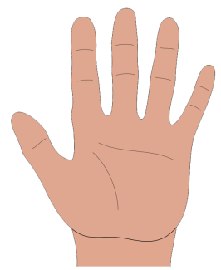  **Hokey Pokey**   
You put your right hand in.

You take your right hand out.

You put your right hand in,

And you shake it all around.

You do the hokey pokey and you turn yourself around,

That’s what it’s all about!

You put your right foot in.

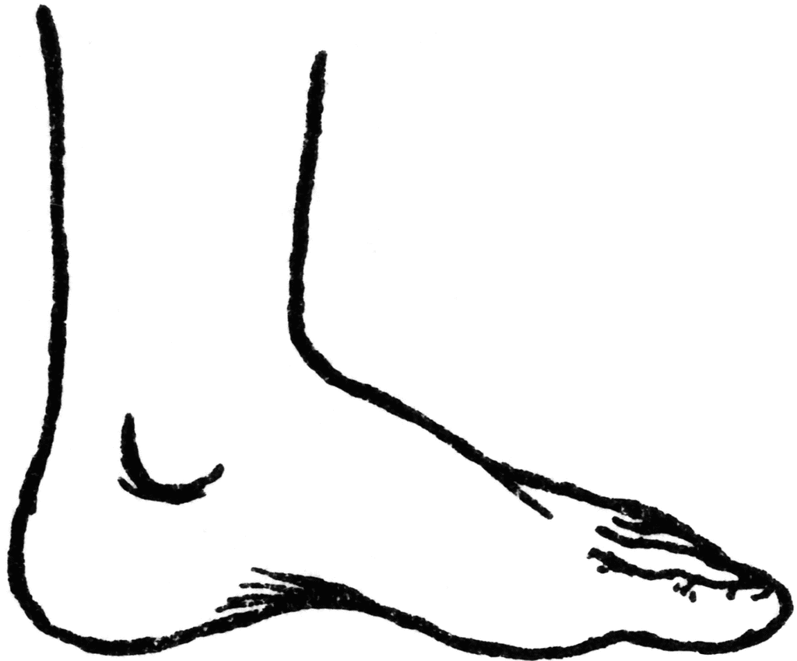You take your right foot out.

You put your right foot in,

And you shake it all around.

You do the hokey pokey and you turn yourself around,

That’s what it’s all about!

|  |
| --- |
| http://www.belau.info/images/bookwebsite.jpg  This happened in the **poem**….  _____________________________________________________________________________________  _____________________________________________________________________________________ |
| http://3.bp.blogspot.com/_AnzziSnCORw/S0c4cg5bBdI/AAAAAAAAAL0/rMBKloHM60E/s320/POSSESSIVE+ADJ.jpg  This happened to **me**…  _____________________________________________________________________________________  _____________________________________________________________________________________ |