**Reading Homework**

**Week of February 29-March 4**

|  |  |
| --- | --- |
| **Monday** | https://s-media-cache-ak0.pinimg.com/236x/c0/5d/08/c05d08d5e60d86c88596514aa69f0c26.jpgRead the poem three times.  https://s-media-cache-ak0.pinimg.com/236x/c0/5d/08/c05d08d5e60d86c88596514aa69f0c26.jpghttps://s-media-cache-ak0.pinimg.com/236x/c0/5d/08/c05d08d5e60d86c88596514aa69f0c26.jpg |
| **Tuesday** | Read the poem.  http://www.cliparthut.com/clip-arts/235/drawing-clip-art-235832.jpegDraw a picture to show what happened in the poem.  https://s-media-cache-ak0.pinimg.com/236x/c0/5d/08/c05d08d5e60d86c88596514aa69f0c26.jpg |
| **Wednesday** | Read the poem.  Find and color the sight words.   * Color ***where*** red. * Color ***there*** green. * https://s-media-cache-ak0.pinimg.com/236x/c0/5d/08/c05d08d5e60d86c88596514aa69f0c26.jpghttp://cdn-4.freeclipartnow.com/d/11571-1/crayon-purple.jpgColor ***down*** blue.   **The cat is happy.** |
| **Thursday** | https://s-media-cache-ak0.pinimg.com/236x/c0/5d/08/c05d08d5e60d86c88596514aa69f0c26.jpgRead the poem and circle the *rhyming words.*  hop pop |
| **Friday** | Read the poem.  https://s-media-cache-ak0.pinimg.com/236x/c0/5d/08/c05d08d5e60d86c88596514aa69f0c26.jpgMake a connection to the poem. Write and draw your connection. |







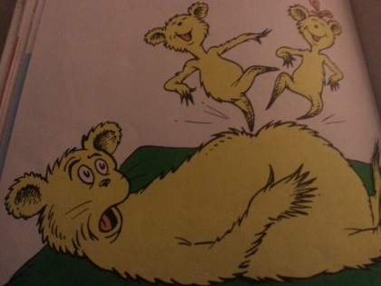 **Hop on Pop**

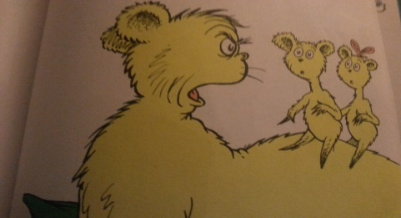HOP. POP.   
We like to hop.

We like to hop on top of Pop.

STOP.

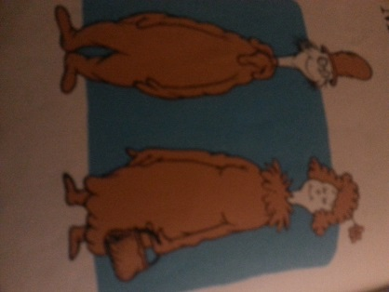You must not hop on Pop.

Mr. Brown, Mrs. Brown

Mr. Brown upside down.

Pup up. Brown down.

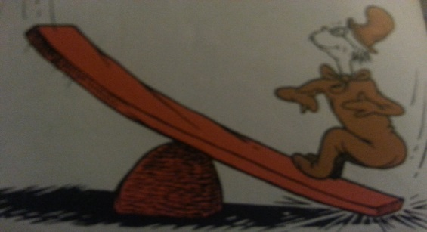Pup is down.

Where is Brown?

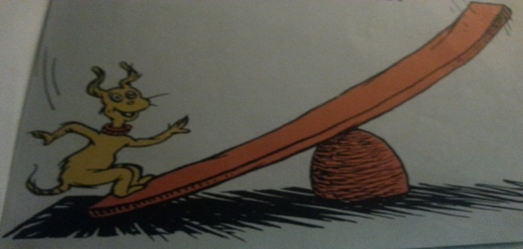WHERE IS BROWN?

THERE IS BROWN!

Mr. Brown is out of town.

|  |
| --- |
| http://www.belau.info/images/bookwebsite.jpg  This happened in the **poem**….  _____________________________________________________________________________________  _____________________________________________________________________________________ |
| http://3.bp.blogspot.com/_AnzziSnCORw/S0c4cg5bBdI/AAAAAAAAAL0/rMBKloHM60E/s320/POSSESSIVE+ADJ.jpg  This happened to **me**…  _____________________________________________________________________________________  _____________________________________________________________________________________ |