**Reading Homework**

**Week of February 16-February 19**

|  |  |
| --- | --- |
| **Tuesday** | Read the poem.  http://www.cliparthut.com/clip-arts/235/drawing-clip-art-235832.jpegDraw a picture to show what happened in the poem.  https://s-media-cache-ak0.pinimg.com/236x/c0/5d/08/c05d08d5e60d86c88596514aa69f0c26.jpg |
| **Wednesday** | Read the poem.  Find and color the sight words.   * Color ***up*** red. * Color ***on*** green. * https://s-media-cache-ak0.pinimg.com/236x/c0/5d/08/c05d08d5e60d86c88596514aa69f0c26.jpghttp://cdn-4.freeclipartnow.com/d/11571-1/crayon-purple.jpgColor ***out***  blue.   **The cat is happy.** |
| **Thursday** | Read the poem and circle the *long vowel sounds with the magic e.*    wave  cape  https://s-media-cache-ak0.pinimg.com/236x/c0/5d/08/c05d08d5e60d86c88596514aa69f0c26.jpg rake |
| **Friday** | Read the poem.  https://s-media-cache-ak0.pinimg.com/236x/c0/5d/08/c05d08d5e60d86c88596514aa69f0c26.jpgMake a connection to the poem. Write and draw your connection. |

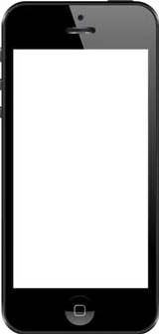

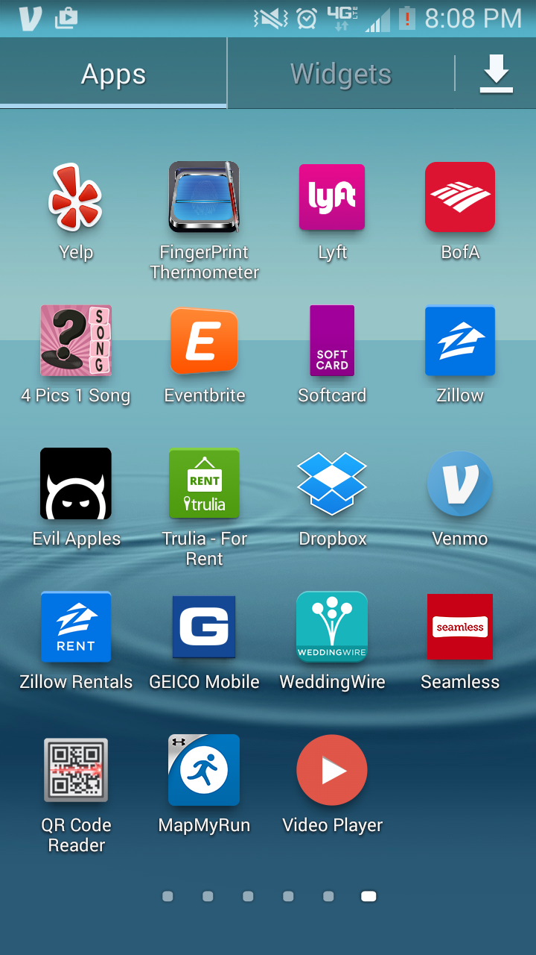

**Jelly in the Bowl**

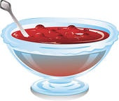Jelly in the bowl,

Jelly in the bowl,

Wibble, wobble, wibble, wobble,

Jelly in the bowl.

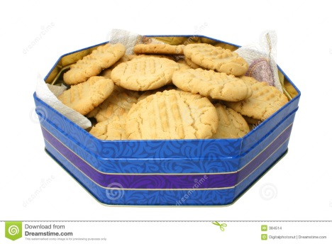

Cookies in the tin,

Cookies in the tin,

Shake em’ up, shake em’ up,

Cookies in the tin.



Candles on the cake,

Candles on the cake,

Blow em’ out, blow em’ out,

Candles on the cake.

|  |
| --- |
| http://www.belau.info/images/bookwebsite.jpg  This happened in the **poem**….  _____________________________________________________________________________________  _____________________________________________________________________________________ |
| http://3.bp.blogspot.com/_AnzziSnCORw/S0c4cg5bBdI/AAAAAAAAAL0/rMBKloHM60E/s320/POSSESSIVE+ADJ.jpg  This happened to **me**…  _____________________________________________________________________________________  _____________________________________________________________________________________ |