**Reading Homework**

**Week of November 9-November 13**

|  |  |
| --- | --- |
| **Monday** | Read the poem 3 times.  https://s-media-cache-ak0.pinimg.com/236x/c0/5d/08/c05d08d5e60d86c88596514aa69f0c26.jpghttps://s-media-cache-ak0.pinimg.com/236x/c0/5d/08/c05d08d5e60d86c88596514aa69f0c26.jpghttps://s-media-cache-ak0.pinimg.com/236x/c0/5d/08/c05d08d5e60d86c88596514aa69f0c26.jpg |
| **Tuesday** | Read the poem.  http://www.cliparthut.com/clip-arts/235/drawing-clip-art-235832.jpegDraw a picture to show what happened in the poem.  https://s-media-cache-ak0.pinimg.com/236x/c0/5d/08/c05d08d5e60d86c88596514aa69f0c26.jpg |
| **Wednesday** | Read the poem.  Find and color the sight words.   * Color ***the*** red. * Color ***up*** green. * https://s-media-cache-ak0.pinimg.com/236x/c0/5d/08/c05d08d5e60d86c88596514aa69f0c26.jpghttp://cdn-4.freeclipartnow.com/d/11571-1/crayon-purple.jpgColor ***one*** blue.   **The cat is happy.** |
| **Thursday** | http://fc09.deviantart.net/fs14/f/2007/052/1/d/Black_dot_by_Myr_Enforcer.jpghttps://s-media-cache-ak0.pinimg.com/236x/c0/5d/08/c05d08d5e60d86c88596514aa69f0c26.jpgRead the poem and circle the words that have the same ending sound as  **The cat is happy.**  . black. |
| **Friday** | Read the poem.  https://s-media-cache-ak0.pinimg.com/236x/c0/5d/08/c05d08d5e60d86c88596514aa69f0c26.jpgMake a connection to the poem. Write and draw your connection. |





**Hickory, Dickory Dock**

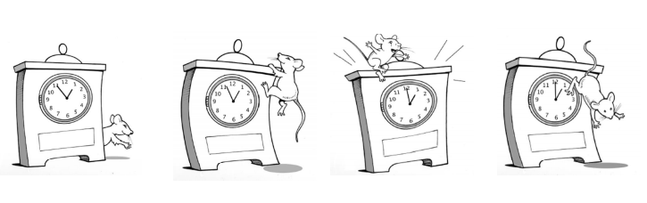

Hickory, dickory dock,

The mouse ran up the clock.

The clock struck one,

The mouse did run,

Hickory, dickory, dock.

|  |
| --- |
| http://www.belau.info/images/bookwebsite.jpg  This happened in the **poem**….  _____________________________________________________________________________________  _____________________________________________________________________________________ |
| http://3.bp.blogspot.com/_AnzziSnCORw/S0c4cg5bBdI/AAAAAAAAAL0/rMBKloHM60E/s320/POSSESSIVE+ADJ.jpg  This happened to **me**…  _____________________________________________________________________________________  _____________________________________________________________________________________ |



