**Reading Homework**

**Week of October 13-October 16**

|  |  |
| --- | --- |
| **Tuesday** | Read the poem 3 times.  https://s-media-cache-ak0.pinimg.com/236x/c0/5d/08/c05d08d5e60d86c88596514aa69f0c26.jpghttps://s-media-cache-ak0.pinimg.com/236x/c0/5d/08/c05d08d5e60d86c88596514aa69f0c26.jpghttp://www.cliparthut.com/clip-arts/235/drawing-clip-art-235832.jpegDraw a picture to show what happened in the poem.  https://s-media-cache-ak0.pinimg.com/236x/c0/5d/08/c05d08d5e60d86c88596514aa69f0c26.jpg |
| **Wednesday** | Read the poem.  Find and color the sight words.   * Color ***on*** red. * Color ***little*** green. * https://s-media-cache-ak0.pinimg.com/236x/c0/5d/08/c05d08d5e60d86c88596514aa69f0c26.jpghttp://cdn-4.freeclipartnow.com/d/11571-1/crayon-purple.jpgColor ***and*** blue.   **The cat is happy.** |
| **Thursday** | http://www.clker.com/cliparts/3/r/z/Z/v/l/triste-sad-hi.pnghttps://s-media-cache-ak0.pinimg.com/236x/c0/5d/08/c05d08d5e60d86c88596514aa69f0c26.jpgRead the poem and circle the words that have the same ending sound as  **The cat is happy.**  .  sad |
| **Friday** | Read the poem.  https://s-media-cache-ak0.pinimg.com/236x/c0/5d/08/c05d08d5e60d86c88596514aa69f0c26.jpgMake a connection to the poem. Write and draw your connection. |



**Five Little Monkeys**

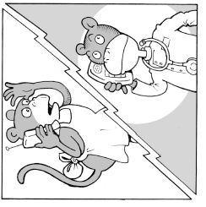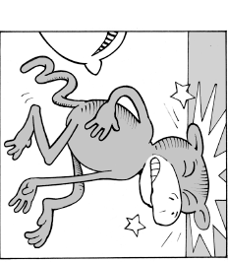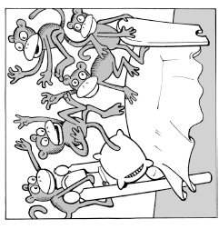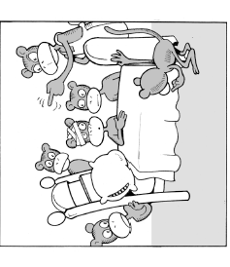

Five little monkeys jumping

on the bed,

One fell off and bumped

his head.

Momma called the doctor and

the doctor said,

“No more monkeys jumping on

the bed!”.

|  |
| --- |
| http://www.belau.info/images/bookwebsite.jpg  This happened in the **poem**….  _____________________________________________________________________________________  _____________________________________________________________________________________ |
| http://3.bp.blogspot.com/_AnzziSnCORw/S0c4cg5bBdI/AAAAAAAAAL0/rMBKloHM60E/s320/POSSESSIVE+ADJ.jpg  This happened to **me**…  _____________________________________________________________________________________  _____________________________________________________________________________________ |

